Raman and DFT Spectroscopic Analysis of Bacterial Lipopolysaccharide (LPS)
Experimental Raman characterization, DFT-simulated vibrational spectra, and reference band assignment

1. Introduction
Lipopolysaccharide (LPS) is the major glycolipid component of the outer membrane of Gram-negative bacteria and a principal driver of the host inflammatory response in sepsis. Raman spectroscopy provides a label-free, non-destructive method for probing the vibrational structure of LPS, while density functional theory (DFT) offers theoretical vibrational frequencies that help interpret and assign the experimental spectrum. This report presents the Raman spectrum of purified LPS, DFT-simulated Raman spectra of its principal structural sub-units, and a comparison of the two used to identify characteristic vibrational bands of LPS.

2. Experimental Raman Spectrum
Lipopolysaccharide from Escherichia coli O111:B4 (phenol-extracted, S-type LPS) was measured as a dry powder using a 785 nm dispersive Raman spectrometer. Spectra were restricted to the 200–2000 cm⁻¹ fingerprint region, baseline-corrected, smoothed, and normalized.
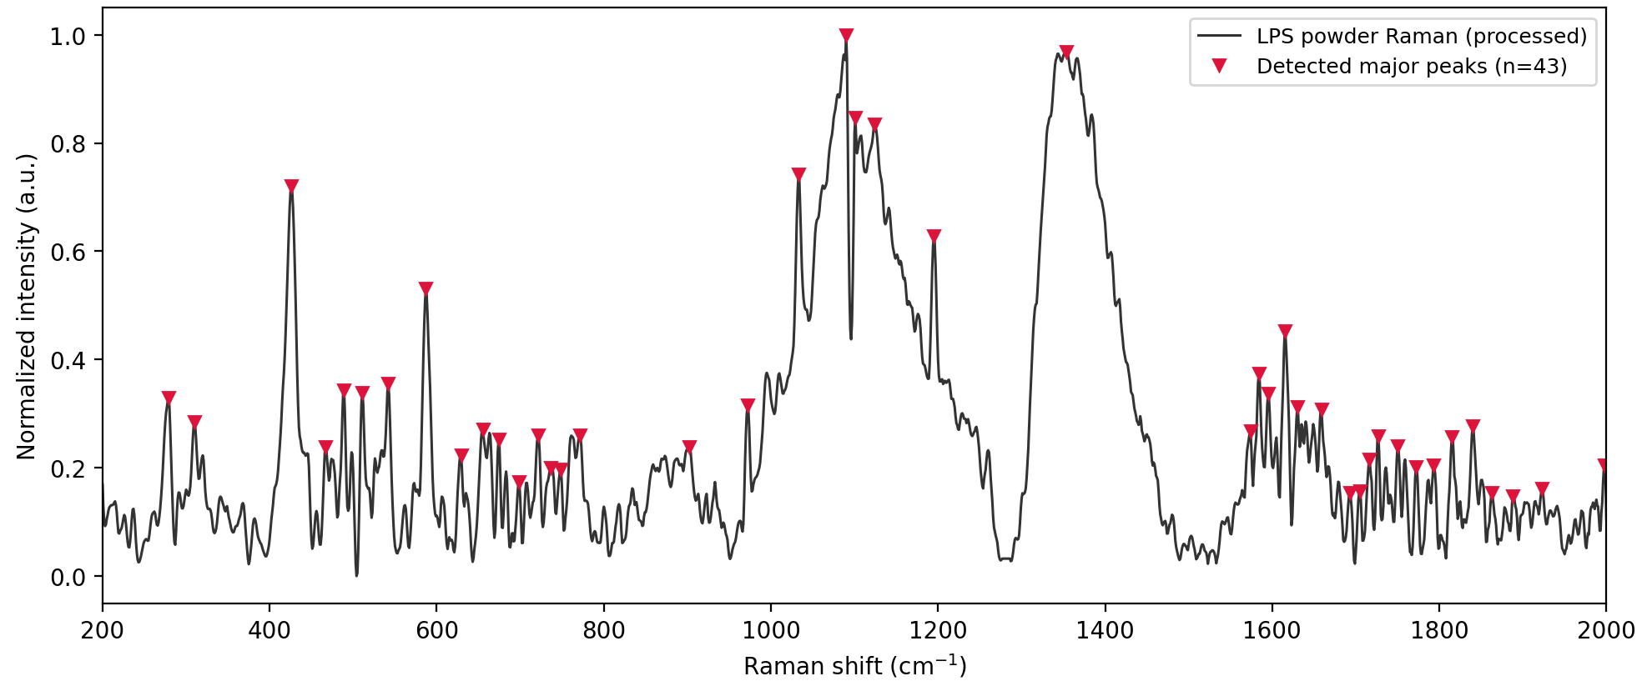
Figure 1. Raman spectrum of LPS powder, with major bands marked (n = 43).
The spectrum shows three principal spectral envelopes: skeletal and ring-deformation modes below 700 cm⁻¹, a strong carbohydrate–phosphate backbone envelope between 900–1200 cm⁻¹ dominated by a band near 1090 cm⁻¹, and a lipid/methylene envelope between 1300–1450 cm⁻¹ dominated by a band near 1350 cm⁻¹ — consistent with the glycolipid composition of LPS.

3. DFT-Simulated Raman Spectra
DFT calculations (B3LYP/6-31G(d) level of theory, harmonic frequencies scaled by 0.9613) were performed for the five principal structural units of LPS: KDO (3-deoxy-D-manno-octulosonic acid), D-glucosamine, heptose, myristic acid, and phosphoric acid — representing the core sugar, backbone-sugar, and lipid A regions of the molecule.
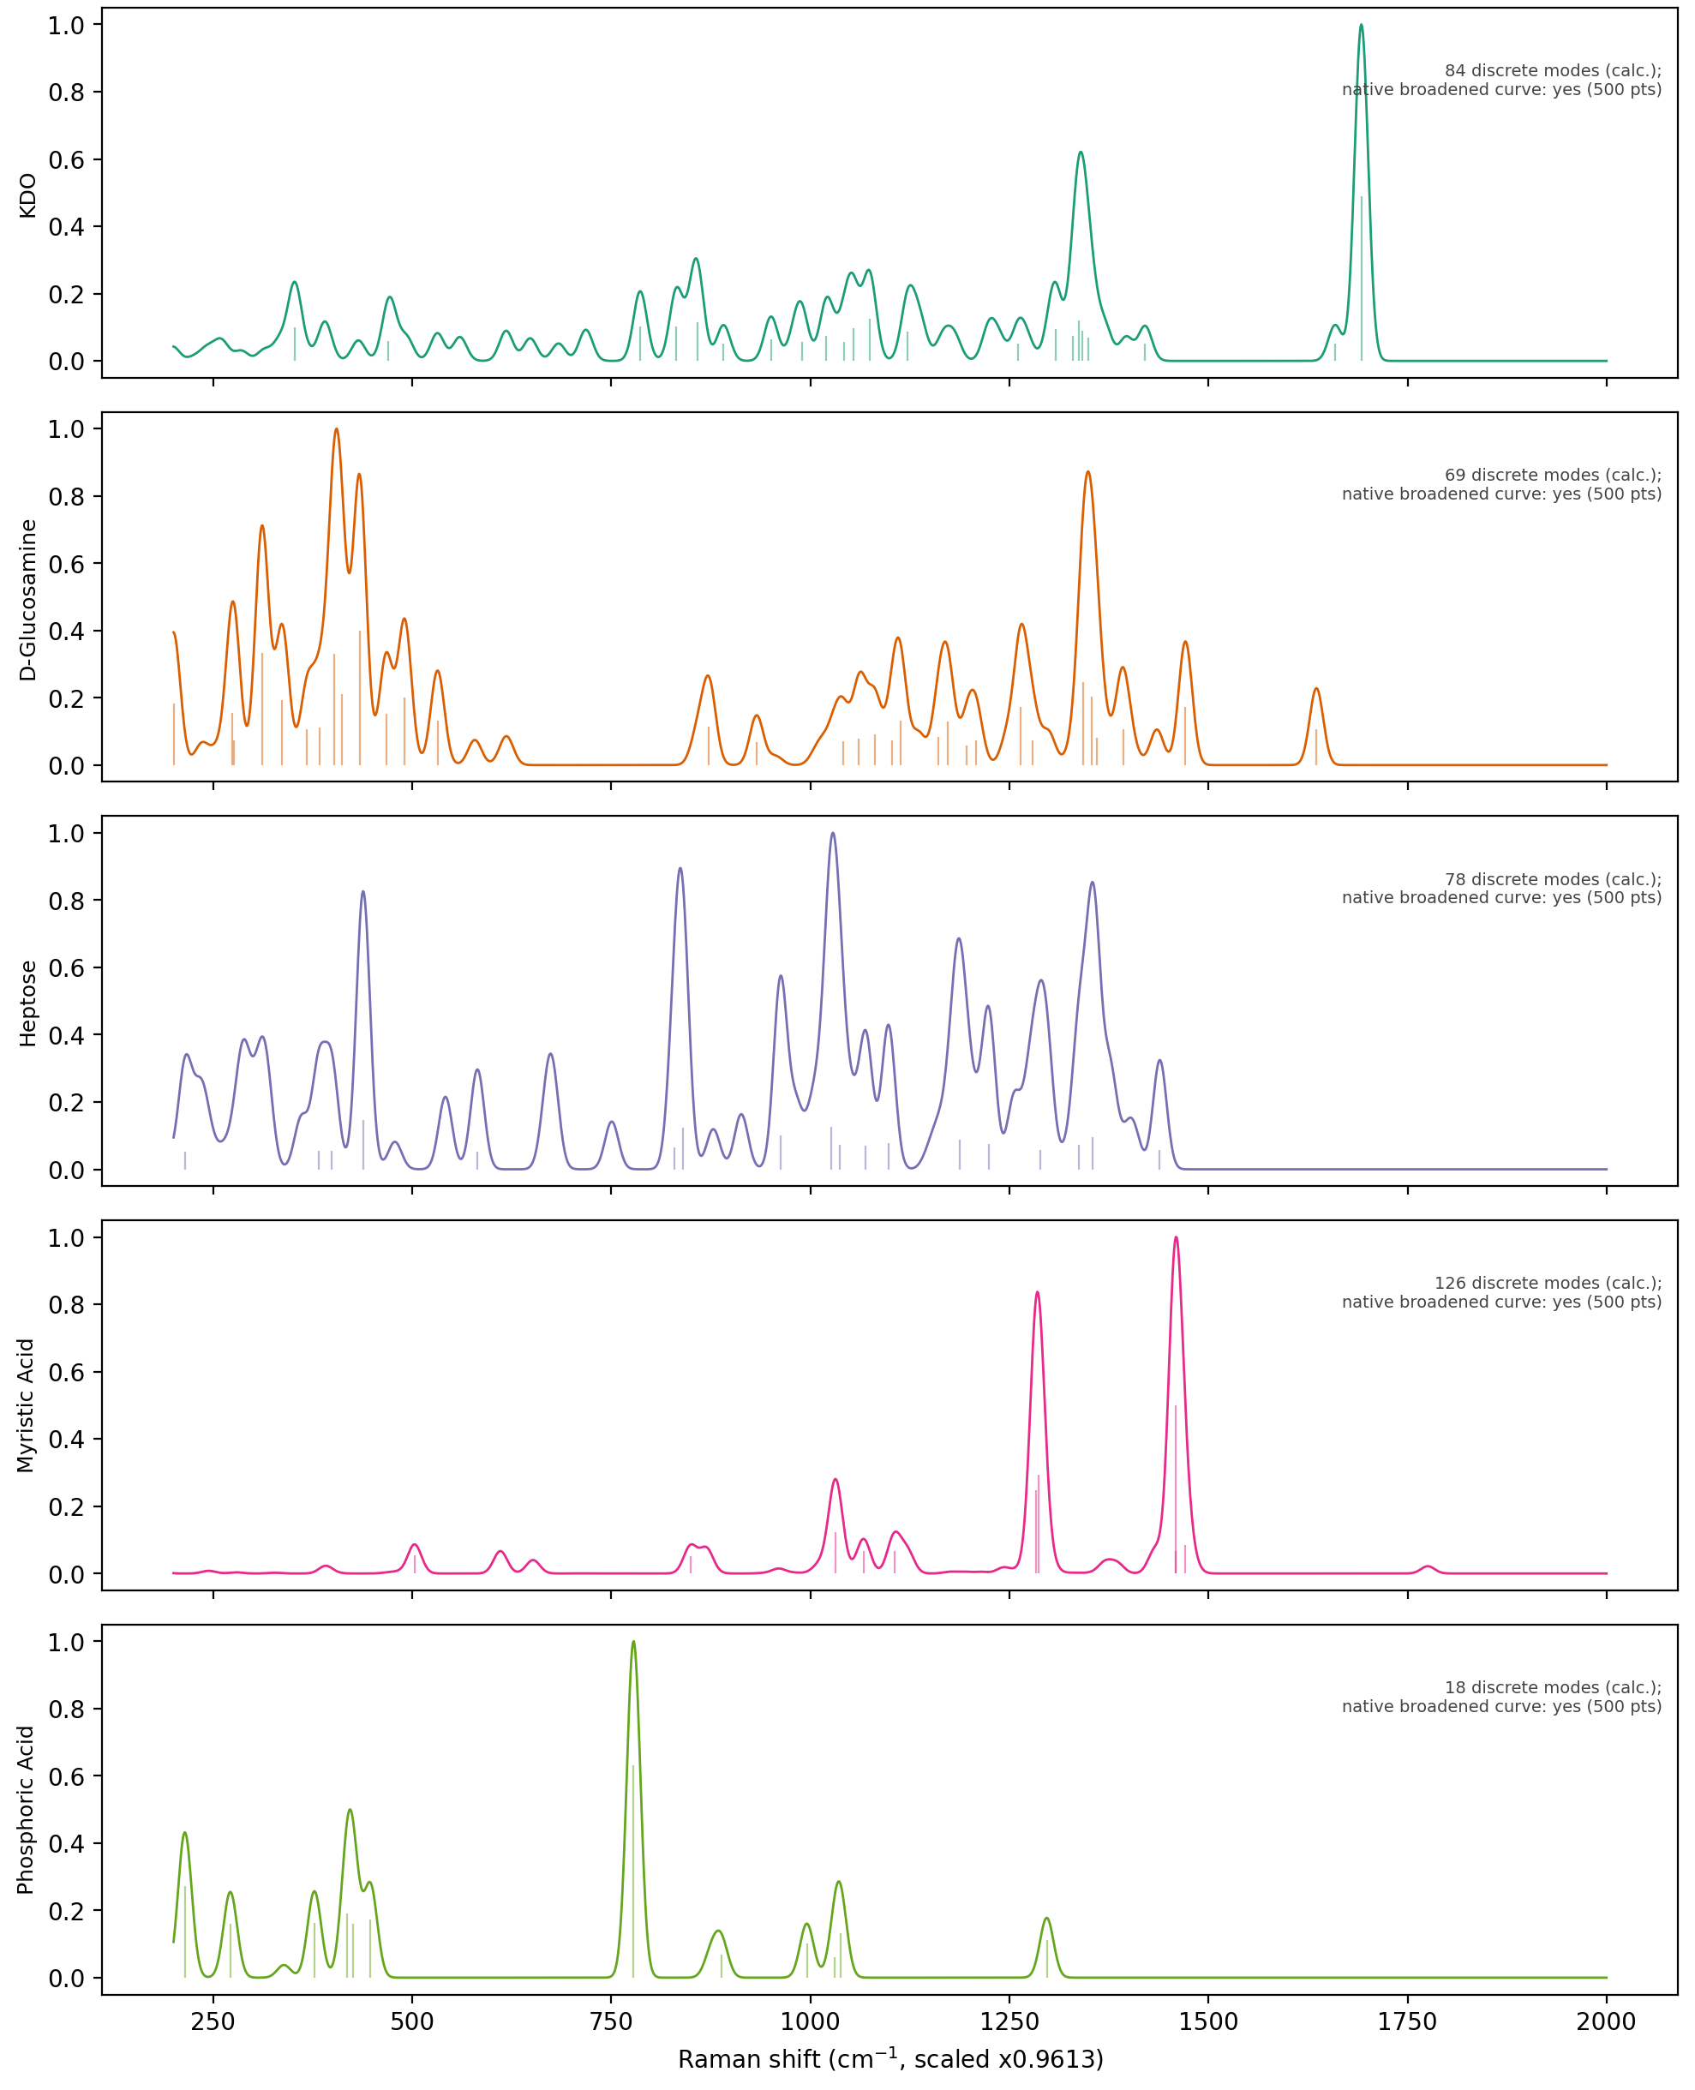
Figure 2. DFT-simulated Raman spectra of the five LPS structural fragments (scaled vibrational modes, shown separately).

4. Comparison of Experimental and DFT Spectra
Experimental peaks were matched to DFT-predicted vibrational modes on a one-to-one basis (Hungarian assignment algorithm), within a ±15 cm⁻¹ tolerance.
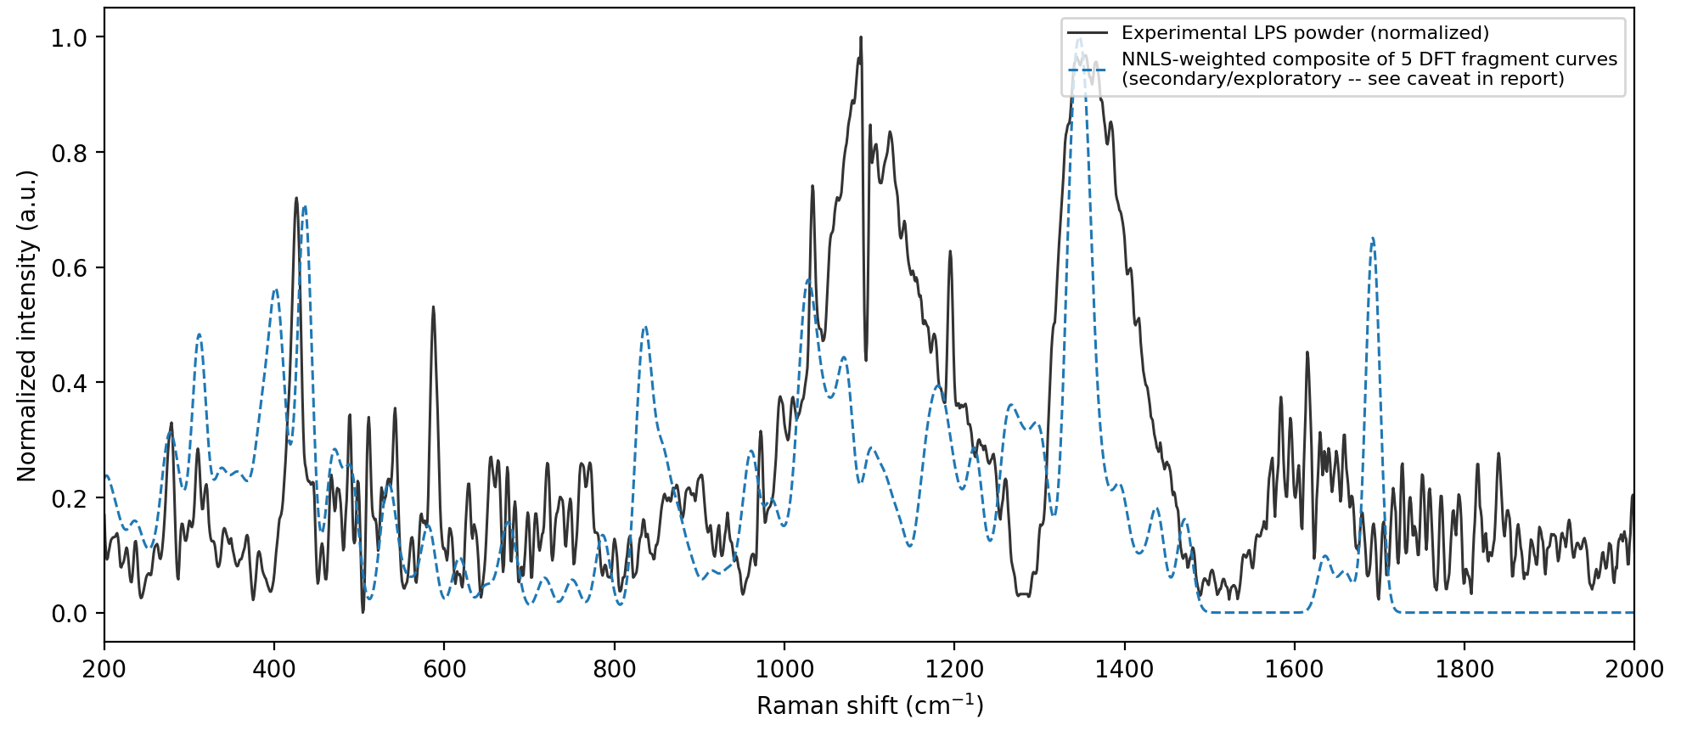
Figure 3. Experimental spectrum overlaid with the composite DFT-derived spectrum.
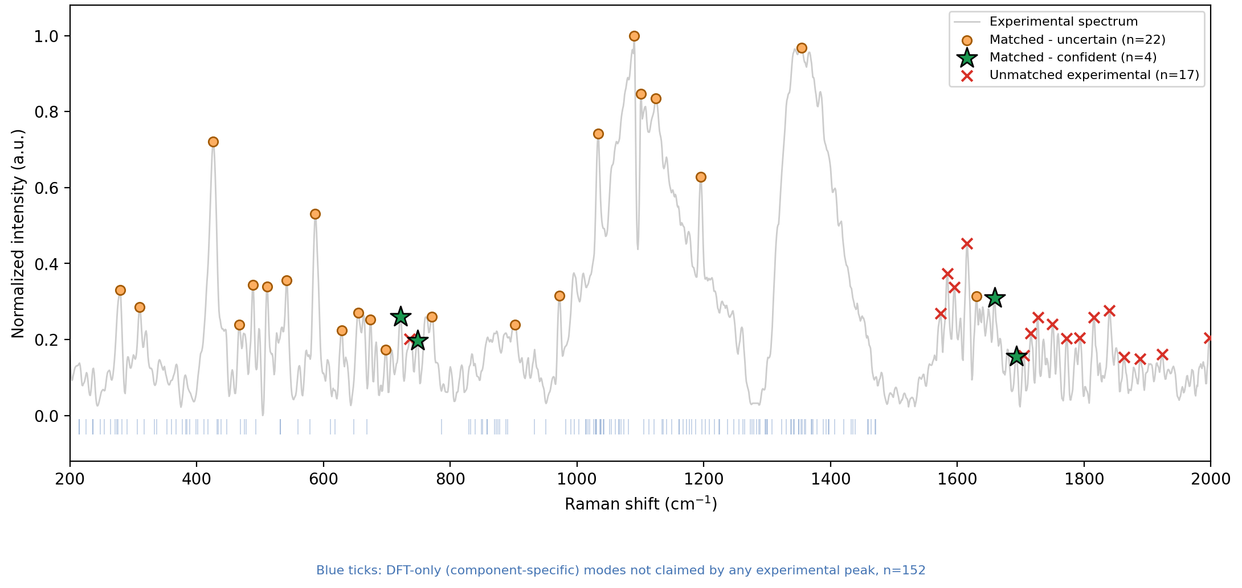
Figure 4. Peak-by-peak matching between the experimental spectrum and DFT-predicted modes.

Quantitative summary
Quantity | Value
Experimental peaks identified | 43
DFT vibrational modes considered | 178
Peaks matched to DFT modes | 26
Closely matched bands (Δ ≤ 5 cm⁻¹) | 4
Mean absolute error, closely matched bands | 1.6 cm⁻¹
Mean absolute error, all matched bands | 3.9 cm⁻¹

5. Characteristic Raman Bands of LPS
Combining the DFT peak-matching results with the literature comparison below, the following Raman bands are identified as characteristic vibrational features of LPS.
Raman shift (cm⁻¹) | Vibrational assignment | Structural origin | Supporting evidence
721 | Ring deformation / C–O–C stretch | KDO | DFT
748 | Skeletal ring vibration | Heptose | DFT
972 | Carbohydrate ring / C–O stretch | Heptose | DFT + literature
1124 | Lipid acyl chain (C–C stretch) | KDO | DFT + literature
1354 | Phospholipid (CH₂ wagging) | KDO | DFT + literature
1659 | Backbone skeletal mode | KDO | DFT
1693 | Backbone skeletal mode | KDO | DFT

6. Comparison with Reported Literature
Four Raman bands reported in the literature for LPS/endotoxin (989, 1131, 1330, and 850 cm⁻¹) were compared against the experimental spectrum. Three fall in close agreement with experimental bands at 972, 1124, and 1354 cm⁻¹, with consistent assignments to carbohydrate-ring, lipid acyl-chain, and phospholipid vibrations respectively.
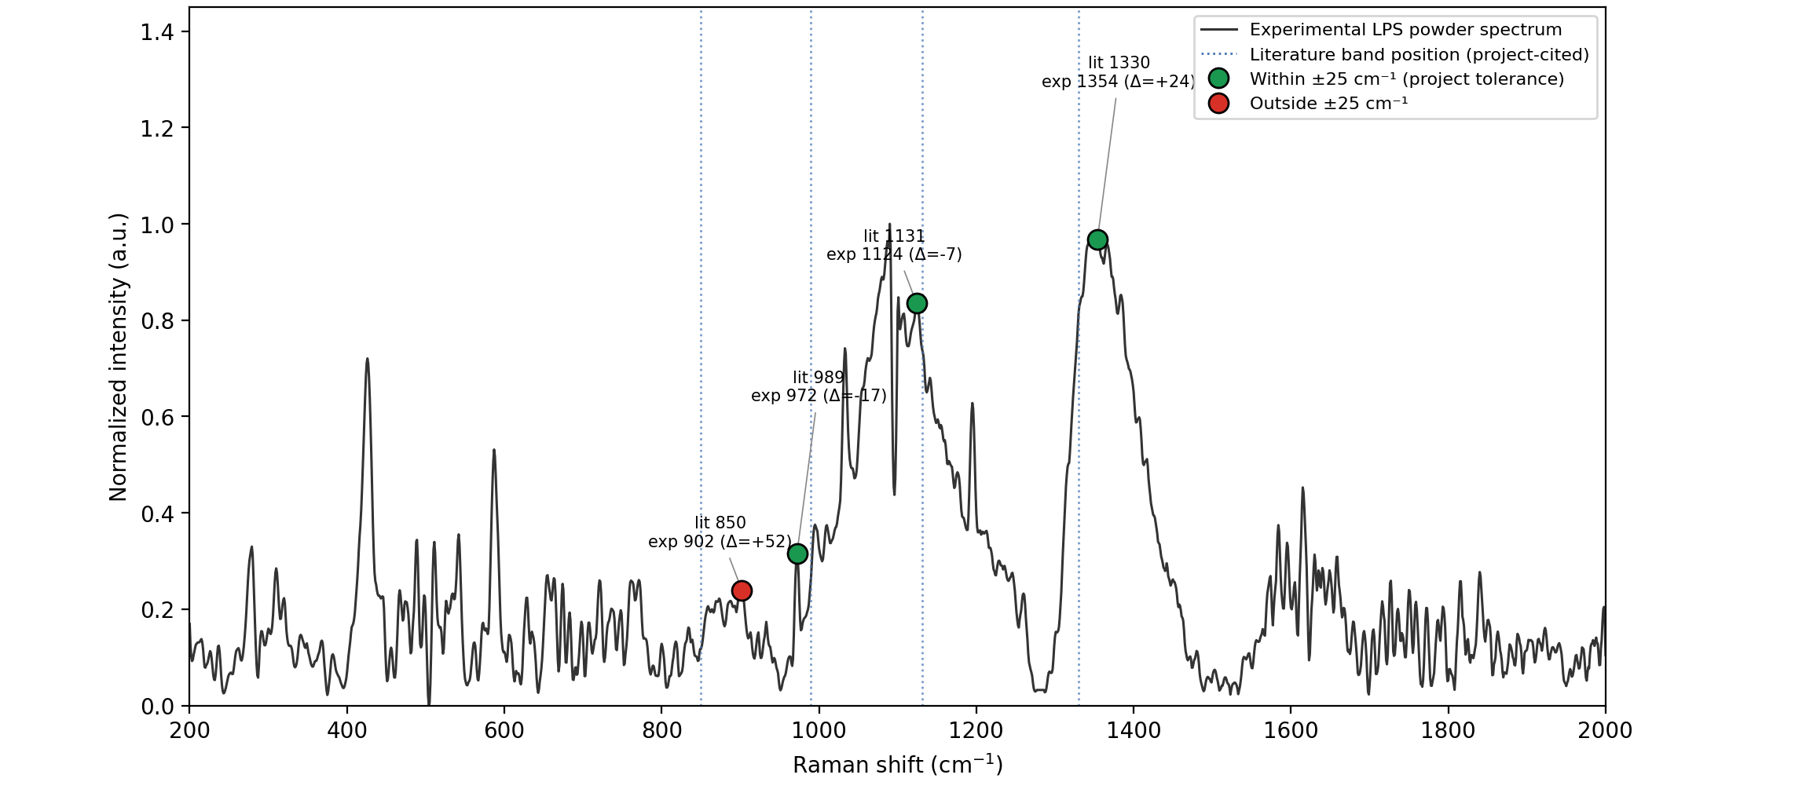
Figure 5. Experimental LPS spectrum compared with literature-reported Raman bands.

7. Conclusion
The combined experimental and DFT-based analysis establishes a consistent set of characteristic Raman bands for LPS, spanning its carbohydrate, phosphate, and lipid structural regions. Four bands (721, 748, 1659, and 1693 cm⁻¹) show close one-to-one agreement with DFT-predicted vibrational modes, and three further bands (972, 1124, and 1354 cm⁻¹) are additionally supported by literature-reported LPS/endotoxin Raman signatures. Together, these seven bands form a reference vibrational fingerprint for LPS that can guide future surface-enhanced Raman (SERS)-based detection and biosensing studies.

